**Methods**

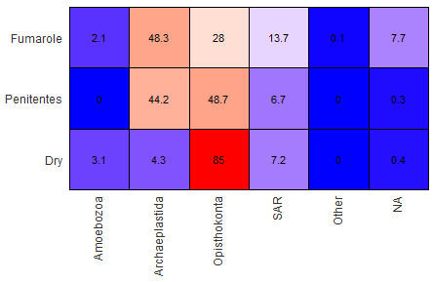

***Figure 1:*** Heat Map for each phylum based on habitat type of a specific abundance percent level. Less than that “limit” is categorized as “other”

Based on *Figure 1*, we can observe there are 3 sample types, represented by what kind of habitat the sample came from.

1. Fumarole Habitat
   1. Openings on the near active volcanoes (and other places) where steam and volcanic gases (SO2 & CO2) are emitted. It can also be assumed that this environment is quite hot.
2. Penitentes Habitat
   1. Snow formations found at high altitudes (more exposure to UV-rays), the cone shaped formations appear to be pointing towards the direction of the sun and each formation is close in proximity.
3. Dry Habitat
   1. Dry habitats are characterized by the lack of moisture/water, temperature fluctuations from day to night. If at lower altitude than Penitentes habitat, then also less UV-radiation.

**Results**

**Alpha Diversity**

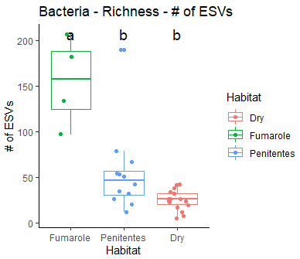

***Figure 2:*** A boxplot of ESV Richness, showing median values and variance of richness with respect to each type of habitat. Statistical summary of richness provides a $\operatorname{Pr}\left(>F\right)=4.15*{{10}^{-7}}^{***}$ The 3 asterisks provides a p-value = 0. Dry, Fumarole, and Penitentes have mean richness values of 25 $±11$, 155 $±49$, and 55 $±47$, respectively.

Based on *Figure 4*, we can observe that the Fumarole habitat had the greatest mean richness. Below in the order, is the Penitentes habitat. Lastly, the Dry habitat had the lowest mean richness. With regards to variance, the order (from highest to lowest) would be the same as it is for species richness. We can also observe that the richness values between the Dry & Penitentes habitats are much closer to one another, while the Fumarole habitat (as a whole) is an outlier with much greater richness values.

Statistical analysis (ANNOVA + TUKEY HSD) of data from *Figure 4*, can be explained by the comparison of species richness between each habitat type. Results of R-Analysis imply there exist significant differences between richness values of each habitat type. More specifically, we can surmise that Fumarole is significantly different in richness value when compared to Dry & Penitentes habitats, while Dry & Penitentes do not demonstrate difference in significance for richness value (i.e. the two habitats are more similar to one another, with regards to ESV richness).

**Beta Diversity-**

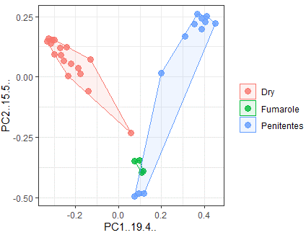

***Figure 3:*** Dissimilarity Matrix (Bray – Curtis) of each habitat type, allowing for inferences regarding differences and similarities in community composition. Via “pmanova” statistical analysis in R-studio, we compared PC1 & PC2 values between each habitat type, where a p-value was determined. Dry vs Fumarole → P-value = 0.01, Dry vs Penitentes → P-value = 0.01, Fumarole vs Penitentes → P-value = 0.01. Implying that the difference in habitat composition for each respective habitat, compared to one another, is statistically significant.

Based on *Figure 3*, we can observe that there are observable differences in community composition in each habitat differ in variance and spread.

With regards to variance (spread of dots within boundary), from largest to smallest, we have Dry, Penitentes, and Fumarole. With regards to spread (space boundaries cover), from largest to smallest, we have Penitentes, Dry, and Fumarole.

Notice how the fumarole has overlapped with the Penitentes, on the surface level, one could argue that there is not much difference in Fumarole in Penitentes habitats. However, that is only looking at one aspect of the graph, as mentioned earlier in my response, there are multiple traits of the figure to consider, such as what I have called “variance” and “spread”. If we consider these two traits, we can not conclude that they aren’t much the same in community composition at all (supported by statistical analysis, p-value < 0.05)

**Core Taxa**

|  |  |  |  |  |
| --- | --- | --- | --- | --- |
| **OTU ID** | **Core Taxa** | **Dry** | **Fumarole** | **Penitentes** |
| ESV_14 | **Eukaryota;** Opisthokonta; Nucletmycea; Fungi; **Piskurozymaceae; Piskurozymaceae**; Piskurozyma_capsuligena | 296.000 | 20.500 | 7.500 |
| ESV_1 | **Eukaryota;** Opisthokonta; Nucletmycea; Fungi; **Filobasidiaceae; Naganishia**; uncultured eukaryote | 2243.647 | 0 | 510.333 |

***Table 1:*** Core taxa shared by all samples based on habitat type. There is a zero for ESV_1 because we had a specification for values that popped up in each environment. The specification IS above zero, so the presence of ESV_1 is still valid, and only appear not present due to parameters set in R-script.

**Geographic Locations of 2 Relatives (for each core taxa)**

ESV 14: GCTACTACCGATTGAATGGCTTAGTGAGATCTCCGGATTGGCTTTGGGAAGCTGGCAACGGCTACCTATTGCTGAGAAGCTGATCAAACTTGGTCATTTAGAGGAAGTAAAAGTCGTAACAAGGTTTCC

Source 1: Piskurozymaceae.

Location: Kansas, USA

Source 2: Piskurozymaceae.

Location: Vancouver, BC, Canada

ESV 1: GCTACTACCGATTGAATGGCTTAGTGAGATCTCCGGATTGGCTTTGGGAAGCTGGCAACGGCTACCCATTGCTGAGAAGCTGATCAAACTTGGTCATTTAGAGGAAGTAAAAGTCGTAACAAGGTTTCC

Source 1: Filobasidiales sp.

Location: Helsinki, Finland

Source 2: Naganishia

Location: Morgantown, WV, USA

**Discussion**

Beta diversity allows one to infer if there are differences in community composition, the exact amount is not provided, but simply a proportion of the different types of microbes present, in our case, with regards to each of the 3 habitats.

An explanation for the trends discovered (refer to results section), would be that at each environment, there is a characteristic set of traits (that differentiates each habitat). It is the physiology of the microbes that determine their adaptations to a given environment, therefore determining (in tandem with results) what type of physiology a microbe would have in order to survive in a given habitat and it’s complimentary environmental conditions (habitat)

Referring to the Hartmann et al. (2009) paper, they attempted to determine community composition of all 3 domains of life in different soil samples. Each sample from different location, demonstrate the community composition of bacteria based on multiple factors. These factors are availability to water and resources, soil composition, oxygen levels, temperature, and pH. The factors stated are things that organisms interact with differently. It was determined that decreasing carbon & nitrogen levels were, increasing pH of the soil was highly correlated with community composition (i.e. some microbes can survive in these conditions, some cannot).

Referring to *Figure 2* of the Hartmann et al. (2009) paper, we can observe a beta diversity visual (similar to the one produced in the Praxis Assignment). Each sample is from a different location, consisting of varying values for pH, nitrogen & carbon compound concentration, and genomic sequences (rather than just location). As we can observe for all 3 domains of live, there are multiple taxa present, some overlapping and some not, some with larger variance, and some without much variance. We are comparing communities “NMS 1 & 2”, from samples collected in Kansas City, indoor environments.

Referring to the Pitkäranta et al. (2007) paper, they attempted to determine community diversity of microbes of dust particles of indoor buildings of varying locations. It was concluded that community composition had a large diversity of organisms (supported by gene analysis). Seasonal variation demonstrated changes in the microbial communities. Implying that some microbes thrive better in a warmer environment over a colder one (vice versa).

In conclusion, each study attempted to determine community composition under difference contexts. However, the similarity between the two (consistent with our Praxis analysis), is that, depending on an organism’s habitat (and the variations of multiple factors), we will arrive at different community compositions. Which makes sense, since on the macro level, this is also the case. A cat from Africa will not be exactly the same as a cat from North America, or even seasonal migration (where community composition changes, due to variation of the habitat). Resulting figures (at a glance) may show similarities, but more often than not, statistical analysis shows significant difference in communities (even ones in close proximity or the same ones changing depending on the season)

**Conclusion**

There are multiple ways we can look at community diversity, Alpha, Beta, and Core taxa are the methods used in the assignment. Each one provided a different perspective, regarding community diversity. Alpha diversity looks as ESV richness (providing insight on the diversity of organisms present), Beta diversity looks at community composition, by comparing two communities based on a factor of interest (in our case, habitat). Core Taxa allows us to determine trends in taxa who are present at all sample locations or habitat elevations.

All of these methods contribute further understanding of how communities (especially microbes) can be extremely diverse (just like with macro biology). Exploration such as this can lead to discoveries (as listed in literature cited) that allows biologists to infer how a community will interact with one another, based on their habitat and the variation present.

The main takeaway is that there are many methods in the analysis of microbiology, where microbial ecology is still a relatively new field. However, even if the organism is too small to realistically observe, there currently exists methods to analyze composition/diversity of microbial communities, and how those communities are affected by their habitat in relation to others. Further insight into this field will provide broader truths for biology as a whole, therefore progressing the field. In other words, analysis of microscopic organisms is not impossible, and has still yet to improve (which will come with time).

**Extra Figures**

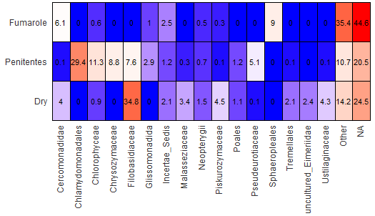

***Figure 4:*** Heat Map for each family based on habitat type of a specific abundance percent level. Less than that limit is categorized as “other”

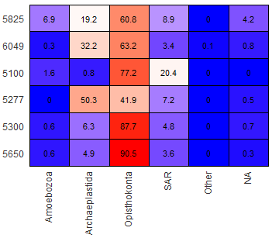

***Figure 5:*** Heat map for each phylum based on elevation of habitat of a specific abundance percent level. Less than that “limit” is categorized as “other”

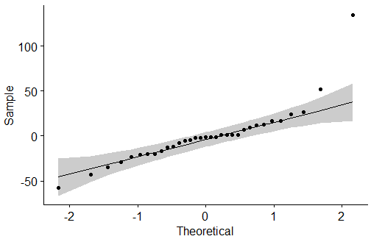

***Figure 6:*** Checking residuals

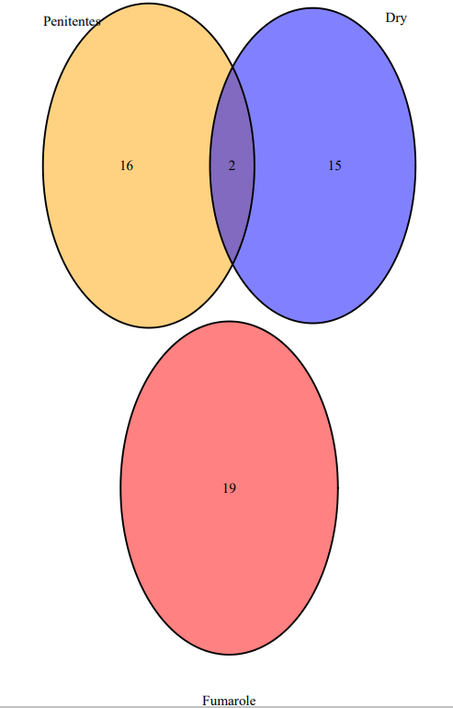

***Figure 7:*** Venn Diagram of shared ESV values between each habitat type, Fumarole(red), Dry(blue), Penitentes(yellow). Differences in habitat type are further supported by *Figure 6* we can observe that the Fumarole habitat does not share any ESVS with the Penitentes or Dry habitats.

**Literature Cited:**

1. Hartmann, M., Lee, S., Hallam, S. J., & Mohn, W. W. (2009). Bacterial, archaeal and eukaryal community structures throughout soil horizons of harvested and naturally disturbed forest stands. *Environmental Microbiology*, *11*(12), 3045–3062. <https://doi.org/10.1111/j.1462-2920.2009.02008.x>

2. Pitkäranta, M., Meklin, T., Hyvärinen, A., Paulin, L., Auvinen, P., Nevalainen, A., & Rintala, H. (2007). Analysis of Fungal Flora in Indoor Dust by Ribosomal DNA Sequence Analysis, Quantitative PCR, and Culture. *Applied and Environmental Microbiology*, *74*(1), 233–244. <https://doi.org/10.1128/aem.00692-07>